

A PROJECT REPORT

ON

“AI BASED DIGITAL CONTENT ORGANIZER”

A project report submitted in partial fulfilment of the requirements for the degree of Bachelor of Technology in Computer Science and Engineering

BACHELOR OF TECHNOLOGY COMPUTER SCIENCE AND ENGINEERING

Submitted By
Radhika Chaudhari (24070521150)

UNDER THE GUIDANCE OF

Dr. Parag Naik

Subject Teacher

DEPARTMENT OF COMPUTER SCIENCE AND ENGINEERING
AY 2026-27
DEPARTMENT OF COMPUTER SCIENCE AND ENGINEERING

CERTIFICATE
This is to certify that the Project work entitled “AI BASED DIGITAL CONTENT ORGANIZER” is carried out by the Radhika Chaudhari, in partial fulfillment for the award of the degree of Bachelor of Technology in Computer Science and Engineering, Symbiosis International (Deemed University), Pune during the academic year 2026-2027.

Dr. Parag Naik  Subject Teacher |  | Dr. Shreyas Rajendra Hole  Subject Coordinator

DECLARATION
I hereby declare that the project titled “AI BASED DIGITAL CONTENT ORGANIZER” submitted to Symbiosis Institute of Technology, a constituent of Symbiosis International (Deemed University) Pune, for the award of the degree of Bachelor of Technology in Computer Science and Engineering, is a result of original research carried out by me. I understand that my report may be made electronically available to the public. It is further declared that the project report or any part thereof has not been previously submitted to any University or Institute for the award of any degree or diploma.
Name of Student 1: Radhika Chaudhari (24070521150)

Degree: Bachelor of Technology in CSE
Department: Computer Science and Engineering
Title of the project: AI BASED DIGITAL CONTENT ORGANIZER

<Student1 Name and Signature>
Date:

Declaration

We hereby declare that the project entitled “AI BASED DIGITAL CONTENT ORGANIZER”, submitted by me for the purpose of processing under the IPR framework, is not an industry-sponsored project.

We further provide my full consent to SIT Nagpur and SCRI Pune to evaluate, process, and proceed with the filing of the Intellectual Property Rights (IPR) application for the said idea.

Student Signature
Radhika Chaudhari

Dr. Shreyas Rajendra Hole

Mr. Parag Naik

ABSTRACT
The AI Based Digital Content Organizer is a machine learning-based application developed to automate the retrieval, classification, and organization of digital content. With the rapid growth of online video platforms, users are exposed to a large volume of content, making manual identification and organization of useful resources time-consuming. The proposed system addresses this problem by combining real-time content retrieval with automated text classification.
The system uses the YouTube Data API v3 to retrieve publicly available video information based on a user-provided search topic. The title and description of each retrieved video are combined and processed as textual input. Term Frequency–Inverse Document Frequency (TF-IDF) is used to convert the text into numerical features, which are then provided to a trained Logistic Regression classifier. The model categorizes videos into predefined categories including Education, Technology, Fitness, Food, Travel, Entertainment, Fashion, and Gaming and provides a corresponding confidence score.
A Gradio-based graphical user interface is used to provide an interactive environment for searching and viewing categorized content. The system also provides a personal content library that allows users to save, search, filter, and manage organized videos for future reference.
The project demonstrates the practical integration of YouTube API, Natural Language Processing, machine learning, and graphical user interface technologies to reduce manual effort in digital content organization. The developed system provides a structured and user-friendly approach for managing online video resources and can be further extended to support additional content sources, categories, languages, and advanced recommendation techniques.

TABLE OF CONTENTS

Page

Certificate i
Declaration ii
Abstract iv
Table of Contents v
CHAPTER 1: BACKGROUND AND TECHNICAL OVERVIEW 1
CHAPTER 2: PROBLEM STATEMENT AND MOTIVATION 4
CHAPTER 3: NOVELTY AND INNOVATIVE CONTRIBUTIONS 6
CHAPTER 4: TECHNICAL ADVANTAGES AND PRACTICAL USEFULNESS 9
CHAPTER 5: DETAILED METHODOLOGY / SYSTEM ARCHITECTURE 6
CHAPTER 6: PRIOR ART AND RELATED WORK (Literature Survey) CHAPTER 7: APPLICATIONS AND DEPLOYMENT AREAS
CHAPTER 8: CONCLUSION AND FUTURE SCOPE 13
CHAPTER 9: GITHUB LINK AND SHORT CODE 14
REFERENCES APPENDICES

Chapter 1
Background and Technical Overview

1.1 Background
The rapid growth of digital platforms has resulted in a large amount of digital content being created and consumed every day. Users frequently search for different types of content such as educational videos, technology-related information, fitness guidance, food, travel, entertainment, fashion, and gaming. As the amount of available content increases, manually identifying and organizing relevant content into suitable categories becomes time-consuming.
The AI Based Digital Content Organizer is developed to provide an automated approach for organizing digital content. The system uses the YouTube Data API v3 to retrieve real-time public video information based on a topic entered by the user. The retrieved video title and description are then processed for classification.
For content classification, the system uses Term Frequency–Inverse Document Frequency (TF-IDF) to convert textual information into numerical features. These features are given to a Logistic Regression machine learning model, which classifies the content into predefined categories such as Education, Technology, Fitness, Food, Travel, Entertainment, Fashion, and Gaming.
The categorized results, along with the predicted category and confidence score, are displayed through a Gradio-based graphical user interface. The system also provides functionality for maintaining a personal content library and storing organized content for future reference.
Thus, the project integrates YouTube API, text processing, machine learning, and graphical user interface technologies to provide an automated and user-friendly solution for digital content organization.

1.2 Objectives
The main objectives of the proposed system are:
- To develop an automated system for organizing digital content into meaningful categories.
- To retrieve real-time digital content using the YouTube Data API v3.
- To classify content using TF-IDF feature extraction and Logistic Regression.
- To categorize content into predefined categories such as Education, Technology, Fitness, Food, Travel, Entertainment, Fashion and Gaming.
- To provide the predicted category along with the model's confidence score.
- To develop an easy-to-use graphical interface using Gradio.
- To allow users to maintain and search a personal library of organized content.
- To store organized content in a structured format for future reference.

1.3 Hardware Components
Since this is a software-based project, no dedicated hardware circuit or electronic components are required.
The basic hardware requirements are:
Component | Requirement
Computer/Laptop | Required for development and execution
Processor | Modern multi-core processor
RAM | Minimum 4 GB; 8 GB or above recommended
Storage | Sufficient storage for Python environment, dataset and project files
Internet Connection | Required for accessing YouTube Data API
Display | Standard laptop/monitor display
The system primarily depends on the computing resources of the user's computer and an active internet connection for retrieving content through the YouTube API.

Chapter 2
Problem Statement and Motivation

2.1 Problem Statement
The rapid increase in digital content on online platforms has made it difficult for users to efficiently identify and organize content according to their interests. Platforms such as YouTube provide a large variety of videos, but users generally have to manually browse, identify, and categorize the content they find useful.
Traditional methods of organizing digital content require manual effort and do not automatically classify newly retrieved content into meaningful categories. This can result in difficulty in managing large amounts of saved content and finding relevant information later.
Therefore, there is a need for an automated digital content organization system that can retrieve real-time content, analyze its textual information, classify it into predefined categories, and present the organized results in a simple and user-friendly manner.
The proposed AI Based Digital Content Organizer addresses this problem by integrating the YouTube Data API v3 with a TF-IDF and Logistic Regression-based machine learning classifier. The system automatically categorizes retrieved videos into predefined categories and provides their classification confidence through a Gradio-based graphical interface, reducing the manual effort required for content organization.

2.2 Motivation
The increasing use of digital platforms has created a large amount of content that users need to search, understand, and organize according to their interests. Although platforms such as YouTube provide powerful search facilities, users still need to manually identify the type of content and organize useful videos for future reference.
The motivation behind this project is to reduce this manual effort by using machine learning for automatic content classification. By analyzing the textual information available in video titles and descriptions, the system can categorize content into predefined categories such as Education, Technology, Fitness, Food, Travel, Entertainment, Fashion, and Gaming.
Another motivation is to combine real-time content retrieval with AI-based classification rather than relying only on a fixed dataset. The integration of the YouTube Data API v3 allows the system to work with newly retrieved public content, while the TF-IDF and Logistic Regression pipeline provides an efficient approach for text classification.
The project also aims to provide a simple interface through Gradio, allowing users to search for content, view its predicted category and confidence, and maintain an organized personal content library. This makes the system useful as a practical application of machine learning, API integration, natural language processing, and user interface development.

Chapter 3
Novelty and Innovative Contributions

3.1 Novelty
The novelty of the AI Based Digital Content Organizer lies in combining real-time digital content retrieval with automatic machine learning-based classification in a single system. Instead of requiring users to manually identify and organize the content they find, the proposed system automatically analyzes the textual information associated with retrieved YouTube videos.
The system uses the YouTube Data API v3 to obtain real-time public video information and combines it with a TF-IDF and Logistic Regression classification pipeline. The retrieved video title and description are analyzed and assigned to predefined categories such as Education, Technology, Fitness, Food, Travel, Entertainment, Fashion, and Gaming.
Another novel aspect is the integration of the classification process with a Gradio-based graphical user interface, where users can directly search for content, view its predicted category and confidence score, and maintain a personal library of organized content.
Thus, the project provides an integrated approach that combines API-based content retrieval, automated text classification, confidence-based prediction, and personal content organization within a single application.

3.2 Innovative Contributions
The major innovative contributions of the proposed system are:
- Real-TimeContentRetrieval:
Integration of the YouTube Data API v3 enables the system to retrieve current public video content based on user-defined search topics.
- AutomatedContentClassification:
The system automatically categorizes retrieved videos using a supervised machine learning model instead of relying on manual categorization.
- TF-IDFBasedTextRepresentation:
Video titles and descriptions are converted into numerical features using TF-IDF before being provided to the classification model.
- LogisticRegressionClassification:
A Logistic Regression model is used to classify content into predefined categories and generate prediction probabilities that are presented as confidence values.
- User-FriendlyGraphicalInterface:
A Gradio-based interface allows users to search, view, and organize content without requiring direct interaction with the underlying code.
- PersonalContentLibrary:
The system provides functionality for storing organized videos and searching or filtering saved content according to categories.
- IntegratedAI-BasedOrganization:
API retrieval, machine learning classification, confidence estimation, and content management are integrated into a single application, providing a complete workflow from content discovery to organization.

Chapter 4
Technical Advantages and Practical Usefulness

4.1 Technical Advantages
The AI Based Digital Content Organizer provides the following technical advantages:
- Automated Classification:
The system automatically classifies retrieved digital content into predefined categories, reducing the need for manual organization.
- Real-Time API Integration:
The integration of the YouTube Data API v3 enables retrieval of current public video information based on user search queries.
- Efficient Text Processing:
TF-IDF converts video titles and descriptions into numerical feature vectors, providing an efficient representation for text classification.
- Machine Learning-Based Prediction:
Logistic Regression provides a lightweight and efficient supervised learning approach for classifying textual content.
- Confidence Estimation:
The system provides a confidence value along with the predicted category, allowing users to understand the model's prediction strength.
- Modular Architecture:
API integration, classification, data storage, and user interface components are separated into different modules, making the system easier to maintain and extend.
- User-Friendly Interface:
The Gradio interface provides an accessible graphical environment for searching and organizing content without requiring programming knowledge.
- Structured Data Storage:
Organized content can be stored in structured formats, making it easier to retrieve, filter, and manage saved content.

4.2 Practical Usefulness
The proposed system can be practically useful in several scenarios:
- Educational Content Organization:
Students can search for educational topics and organize relevant videos under categories such as Education and Technology.
- Personal Content Management:
Users can maintain a personal library of useful videos instead of manually maintaining separate lists or bookmarks.
- Content Discovery:
Users can enter a topic of interest and obtain categorized search results, making it easier to identify the type of content available.
- Learning Resource Management:
Students and learners can organize tutorials, lectures, programming resources, and other learning materials for future reference.
- Interest-Based Organization:
Content related to areas such as Fitness, Food, Travel, Fashion, Gaming, and Entertainment can be automatically grouped into their respective categories.
- Reduced Manual Effort:
Automatic classification reduces the time required to manually inspect and categorize every retrieved video.
- Future Content Management Applications:
The same approach can be extended to other forms of textual digital content, provided suitable data sources and classification categories are available.
Overall, the system demonstrates how machine learning and API integration can be applied to automate the organization of digital content in a practical and user-friendly manner.

Chapter 5
Detailed Methodology / System Architecture

5.1 System Architecture
The AI Based Digital Content Organizer follows a modular software architecture consisting of content retrieval, text processing, machine learning classification, and user interface components.
The overall system architecture can be represented as:
User Input
↓
Gradio Graphical User Interface
↓
YouTube Data API v3
↓
Video Title + Description Retrieval
↓
Text Pre-processing
↓
TF-IDF Feature Extraction
↓
Logistic Regression Classifier
↓
Category + Confidence Score
↓
Organized Content Display
↓
Personal Content Library / Structured Storage
Main Components
- User Interface:
The Gradio interface accepts a search topic from the user and displays the organized results.
- YouTube API Module:
The YouTube Data API v3 retrieves public video information such as title, description, channel, publication date, thumbnail, and video URL.
- Text Processing Module:
The retrieved title and description are combined and prepared as textual input for classification.
- TF-IDF Feature Extraction:
The text is converted into numerical feature vectors using Term Frequency–Inverse Document Frequency.
- Machine Learning Classifier:
The Logistic Regression model predicts the appropriate content category and provides prediction probabilities.
- Content Organization Module:
Videos are grouped according to their predicted categories and displayed to the user.
- Personal Library:
Users can save and manage organized content for future reference.

5.2 Working Principle
The working of the system takes place through the following steps:
- User enters a search topic:
The user enters a topic or keyword through the Gradio interface.
- API request is generated:
The system sends the search query to the YouTube Data API v3.
- Video information is retrieved:
The API returns publicly available information such as video title, description, channel name, thumbnail, publication date, and video ID.
- Text is prepared:
The video title and description are combined to form the textual input for the machine learning model.
- TF-IDF transformation:
The textual input is converted into numerical features using the trained TF-IDF vectorizer.
- Content classification:
The generated feature vector is passed to the trained Logistic Regression model.
- Category prediction:
The model predicts one of the predefined categories: Education, Technology, Fitness, Food, Travel, Entertainment, Fashion, or Gaming.
- Confidence calculation:
The prediction probability is obtained from the model and displayed as the confidence score.
- Content organization:
Retrieved videos are grouped according to their predicted categories and displayed through the Gradio interface.
- Library storage:
Users can save the organized content to their personal library for later searching and filtering.

5.3 Circuit Connections
Since the AI Based Digital Content Organizer is a software-based project, it does not contain physical electronic circuits, sensors, microcontrollers, or hardware components. Therefore, no electrical circuit connections are required.
Instead of physical circuit connections, the project uses software module connections between its major components:
Component | Connection
User | Provides search query through Gradio
Gradio Interface | Sends query to the YouTube API module
YouTube Data API v3 | Returns video metadata
Text Processing | Combines video title and description
TF-IDF Vectorizer | Converts text into numerical features
Logistic Regression | Predicts content category
Content Organizer | Groups videos by category
Personal Library | Stores and retrieves organized content
Software Flow:
User → Gradio → YouTube API → Text Processing → TF-IDF → Logistic Regression → Category & Confidence → Organized Content → Personal Library
Thus, for this software project, the software module interaction diagram serves as the equivalent of circuit connections specified in the general report template.

5.4 Simulation
Since the AI Based Digital Content Organizer is a software-based project, simulation is performed by executing the developed application and testing its complete workflow in a software environment. No physical hardware simulation is required.
The system is tested using different search topics through the Gradio interface. For each search query, the application communicates with the YouTube Data API v3, retrieves relevant public videos, and passes their titles and descriptions to the trained machine learning model.
The simulation process follows these steps:
- Launch the application using the Python environment.
- Open the Gradio-based graphical interface.
- Enter a search topic such as Python Programming, Fitness Workout, or Travel.
- Send the search request to the YouTube Data API.
- Retrieve the available video information.
- Process the video title and description using the trained TF-IDF vectorizer.
- Apply the Logistic Regression classifier.
- Display the predicted category and confidence score.
- Group the retrieved videos according to their predicted categories.
- Save selected results to the personal content library.
The simulation verifies the interaction between the major software modules and demonstrates that the system can perform content retrieval, classification, categorization, and storage through a single user interface.
Simulation Output
The expected output of the system includes:
- Video title and thumbnail
- YouTube channel name
- Video description
- Predicted content category
- Classification confidence
- Video link
- Organized category-wise results
- Personal content library

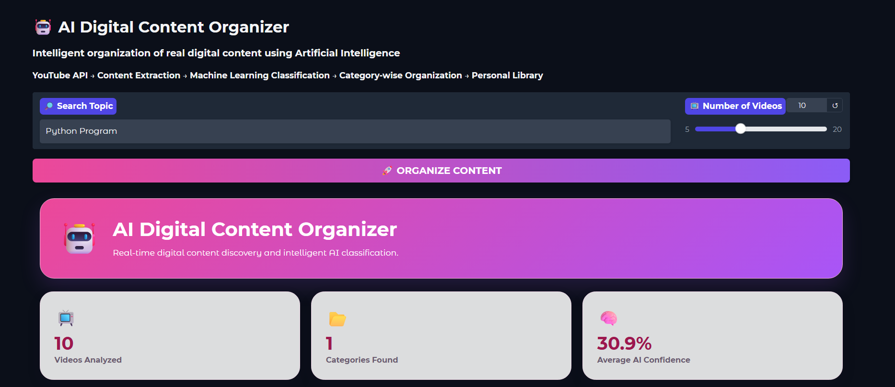

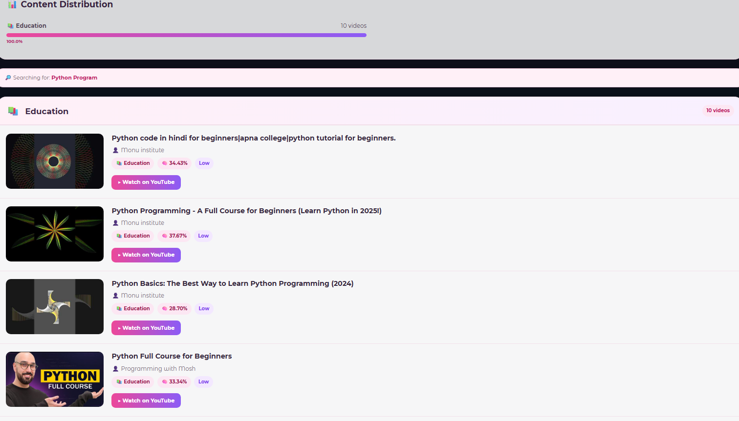

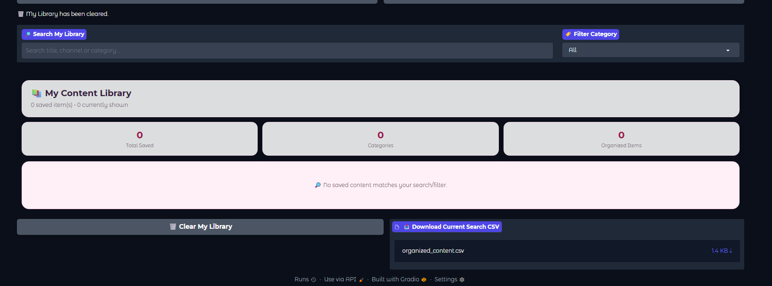

Chapter 6
Prior Art and Related Work (Literature Survey)

6.1 Introduction
The rapid growth of online video platforms has created a large volume of digital content covering education, technology, entertainment, fitness, travel, food, and other domains. Organizing such content manually can be time-consuming, particularly when users need to manage a large number of resources.
Various existing technologies have addressed individual aspects of this problem, including content-based information retrieval, text classification, natural language processing, machine learning-based categorization, and recommendation systems. These approaches provide the foundation for developing systems that can automatically analyze and organize digital content.
The proposed AI Based Digital Content Organizer combines these concepts into a single application. It retrieves public video information through the YouTube Data API v3 and uses TF-IDF and Logistic Regression to classify content based on video titles and descriptions. The literature survey therefore focuses on technologies and approaches related to text representation, supervised text classification, online video analysis, and automated content organization.

6.2 Existing Technologies
Several technologies are relevant to the development of an automated digital content organization system.
1. YouTube Data API
The YouTube Data API provides programmatic access to publicly available YouTube resources. Applications can use the API to search for videos and retrieve information such as titles, descriptions, channel details, thumbnails, and publication information. In the proposed system, the API is used as the primary source for retrieving real-time digital content.
2. Natural Language Processing
Natural Language Processing (NLP) techniques are used to process and analyze human-readable text. In this project, the title and description of a video are treated as textual data and converted into a format that can be processed by a machine learning model.
3. TF-IDF
Term Frequency–Inverse Document Frequency (TF-IDF) is a commonly used technique for representing text numerically. It assigns higher importance to terms that are frequent in a particular document but less common across the overall collection. TF-IDF is used in the proposed system to convert video text into numerical feature vectors.
4. Logistic Regression
Logistic Regression is a supervised machine learning algorithm that can be applied to classification problems. In the proposed system, it is trained to classify textual content into predefined categories based on the extracted TF-IDF features.
5. Gradio
Gradio is a Python-based framework for creating interactive interfaces for machine learning applications. It is used in the proposed system to provide a graphical interface through which users can enter search topics and view classified content.
6. Content Management and Storage
Structured data storage can be used to maintain information about categorized content. The proposed system provides a personal content library through which users can save, search, filter, and manage organized videos.

6.3 Related Work
Previous research and existing applications have explored different approaches to automated content analysis and organization. Text classification techniques have been widely used for assigning documents to predefined categories. Traditional machine learning methods such as Naive Bayes, Support Vector Machines, and Logistic Regression have been applied to text classification using feature extraction techniques such as TF-IDF.
Research in Natural Language Processing has also demonstrated the usefulness of converting textual information into numerical representations before applying classification algorithms. These approaches form the basis for classifying video titles and descriptions in the proposed system.
Online video platforms have also introduced automated methods for search, recommendation, categorization, and personalization. Such systems help users discover content from large collections. However, recommendation systems generally focus on suggesting content based on user behaviour, viewing history, or relevance, whereas the proposed project focuses specifically on categorizing retrieved content into predefined user-understandable categories.
The proposed system combines these concepts by using real-time YouTube content as input and applying a lightweight supervised classification pipeline. Instead of depending only on manual categorization, the system uses the textual information associated with each video to determine its category and display a corresponding confidence value.

6.4 Summary
The literature survey shows that several technologies are available for digital content retrieval, text processing, classification, and recommendation. NLP and TF-IDF provide suitable methods for representing textual information, while supervised machine learning algorithms can be used to classify content into predefined categories.
The YouTube Data API provides access to public video information, making it possible to use current online content as input. The proposed system combines these technologies with Logistic Regression and a Gradio interface to create an automated digital content organization workflow.
The key distinction of the proposed system is the integration of real-time content retrieval and automated category-based organization with a personal content library. This provides a practical implementation of machine learning and API integration for managing digital content.

Chapter 7

Applications and Deployment Areas

7.1 Applications
The AI Based Digital Content Organizer can be used in various situations where digital content needs to be searched, classified, and organized automatically.
- Educational Resource Organization:
Students can use the system to find and organize tutorials, lectures, programming videos, and other educational resources.
- Personal Content Management:
Users can save useful videos in their personal content library and access them later according to their categories.
- Technology Content Organization:
Programming tutorials, software-related videos, and technology discussions can be automatically classified under the Technology category.
- Fitness and Health Content Organization:
Workout-related and fitness guidance videos can be grouped under the Fitness category for easier access.
- Travel and Food Content Management:
Travel guides, destination videos, recipes, and cooking-related content can be organized into their respective categories.
- Entertainment and Gaming Content:
Entertainment and gaming videos can be automatically identified and grouped, reducing the effort required for manual organization.
- Learning and Research:
Users can collect and organize digital resources related to a particular subject for future learning and reference.

7.2 Deployment Areas
The proposed system can be deployed in the following areas:
- Educational Institutions:
Colleges, schools, and training institutes can use similar systems to organize digital learning resources for students.
- Personal Learning Platforms:
Individual learners can use the system to maintain categorized collections of online educational content.
- Content Management Applications:
The classification approach can be incorporated into applications that require automatic categorization of large collections of textual digital content.
- Digital Libraries:
The system can be adapted for organizing video-based resources in digital libraries according to predefined categories.
- Training and Skill Development:
Training platforms can use automated classification to organize instructional videos into different subject or skill categories.
- Future Web and Media Applications:
The underlying classification approach can be extended to other digital content sources where textual metadata such as titles and descriptions is available.
The system can therefore serve as a practical foundation for applications involving automated digital content retrieval, classification, and organization.

Chapter 8 Conclusion and Future Scope

8.1 Conclusion
The AI Based Digital Content Organizer successfully demonstrates an automated approach for retrieving, classifying, and organizing digital content. The system integrates the YouTube Data API v3 to retrieve real-time public video information and uses the video's title and description as input for machine learning-based classification.
The combination of TF-IDF feature extraction and Logistic Regression enables the system to categorize retrieved videos into predefined categories such as Education, Technology, Fitness, Food, Travel, Entertainment, Fashion, and Gaming. The predicted category and confidence score are presented through a Gradio-based graphical user interface, making the system simple and accessible for users.
The project also provides a personal content library that allows users to store, search, filter, and manage organized content. Thus, the project demonstrates the practical integration of API development, Natural Language Processing, supervised machine learning, data organization, and graphical user interface development in a single application.
Overall, the developed system reduces the manual effort involved in organizing digital content and provides a structured approach for managing online video resources.

8.2 Future Scope
The system can be further enhanced in the following ways:
- Advanced Machine Learning Models:
More advanced NLP models such as BERT or other transformer-based models can be explored to improve classification of complex textual content.
- Support for Additional Platforms:
The system can be extended to support other digital content platforms and sources in addition to YouTube.
- More Content Categories:
Additional categories can be introduced to provide more detailed organization of digital content.
- Personalized Recommendations:
A recommendation module can be added to suggest content based on the user's saved library, search history, and selected interests.
- Multilingual Content Classification:
Support for multiple languages can be introduced to classify content written in languages other than English.
- Improved Content Analysis:
Future versions can analyze additional metadata such as captions, tags, and other available textual information to improve classification.
- Cloud-Based Deployment:
The application can be deployed on a cloud platform so that users can access their organized content from different devices.
- Advanced Search and Filtering:
More advanced filters such as category, confidence level, channel, date, and topic can be introduced for easier content discovery.
- Mobile Application:
A mobile version can be developed to provide convenient access to the personal content library.
- Continuous Model Improvement:
The classification model can be periodically retrained using newly collected and manually verified data to improve its performance as the type of digital content changes.

References / Bibliography
- Google for Developers, “YouTube Data API – Search: list,” YouTube Data API v3 Documentation.
- Google for Developers, “YouTube Data API v3 Documentation,” Google Developers.
- Google for Developers, “Sample API Requests – YouTube Data API,” Google Developers.
- Google for Developers, “Implementation: Search Requests – YouTube Data API,” Google Developers.
- Scikit-learn Developers, “TfidfVectorizer,” Scikit-learn Documentation.
- Scikit-learn Developers, “LogisticRegression,” Scikit-learn Documentation.
- Gradio Team, “Gradio API Documentation,” Gradio Documentation.
- F. Sebastiani, “Machine Learning in Automated Text Categorization,” ACM Computing Surveys, vol. 34, no. 1, pp. 1–47, 2002.
- T. Joachims, “Text Categorization with Support Vector Machines: Learning with Many Relevant Features,” Proceedings of the European Conference on Machine Learning (ECML), 1998.
- C. D. Manning, P. Raghavan, and H. Schütze, Introduction to Information Retrieval, Cambridge University Press, 2008.
- J. Han, M. Kamber, and J. Pei, Data Mining: Concepts and Techniques, 3rd ed., Morgan Kaufmann, 2011.
- S. Bird, E. Klein, and E. Loper, Natural Language Processing with Python, O'Reilly Media, 2009.
- G. Salton and C. Buckley, “Term-weighting approaches in automatic text retrieval,” Information Processing & Management, vol. 24, no. 5, pp. 513–523, 1988.
Web References
- YouTube Data API Documentation
- YouTube Search: list Documentation
- Scikit-learn Documentation
- TF-IDF Vectorizer Documentation
- Logistic Regression Documentation
- Gradio Documentation

